Luis Ruiz

PSCS 2302

Timothy Losito  
March 8, 2022

Assignment 3 – Recovering Graphic Files

This assignment will focus on manually recovering graphic files from a drive image. The image used for this assignment contains 3 JPG files. All three of the files have been deleted, however the files still exist on the drive and can be manually recovered.

Assignment

Using FTK Imager, search for and recover the three missing graphic files. Once the files have been located, export the **physical** files from the drive image and then use the application “HashMyFiles” to calculate the MD5 and SHA1 hash values for each file. Insert the recovered image files into this document along with the below information for each file.

*Note: Don’t forget the difference between logical file size and physical file size.*

Information for First Recovered File

Starting Physical Sector Number:408

Starting Cluster Number:35

Ending Physical Sector Number:480

Ending Cluster Number:44

Physical size in bytes:36864

Carved File MD5 Hash: 6e5df8e134eb20ce570c7058733fc070

Carved File SHA1 Hash: 84147582b8fe21f8c52b1d511e165ac732d919f3

Insert Recovered Image Below:



Information for Second Recovered File

Starting Physical Sector Number:13744

Starting Cluster Number:1702

Ending Physical Sector:14328

Ending Cluster Number:1775

Physical size in bytes:299008

Carved File MD5 Hash: 1534d38d67c5d2d736861d3e530725db

Carved File SHA1 Hash: a43302aafa9a4737d1ab1055430946c5693edfd2

Insert Recovered Image Below:

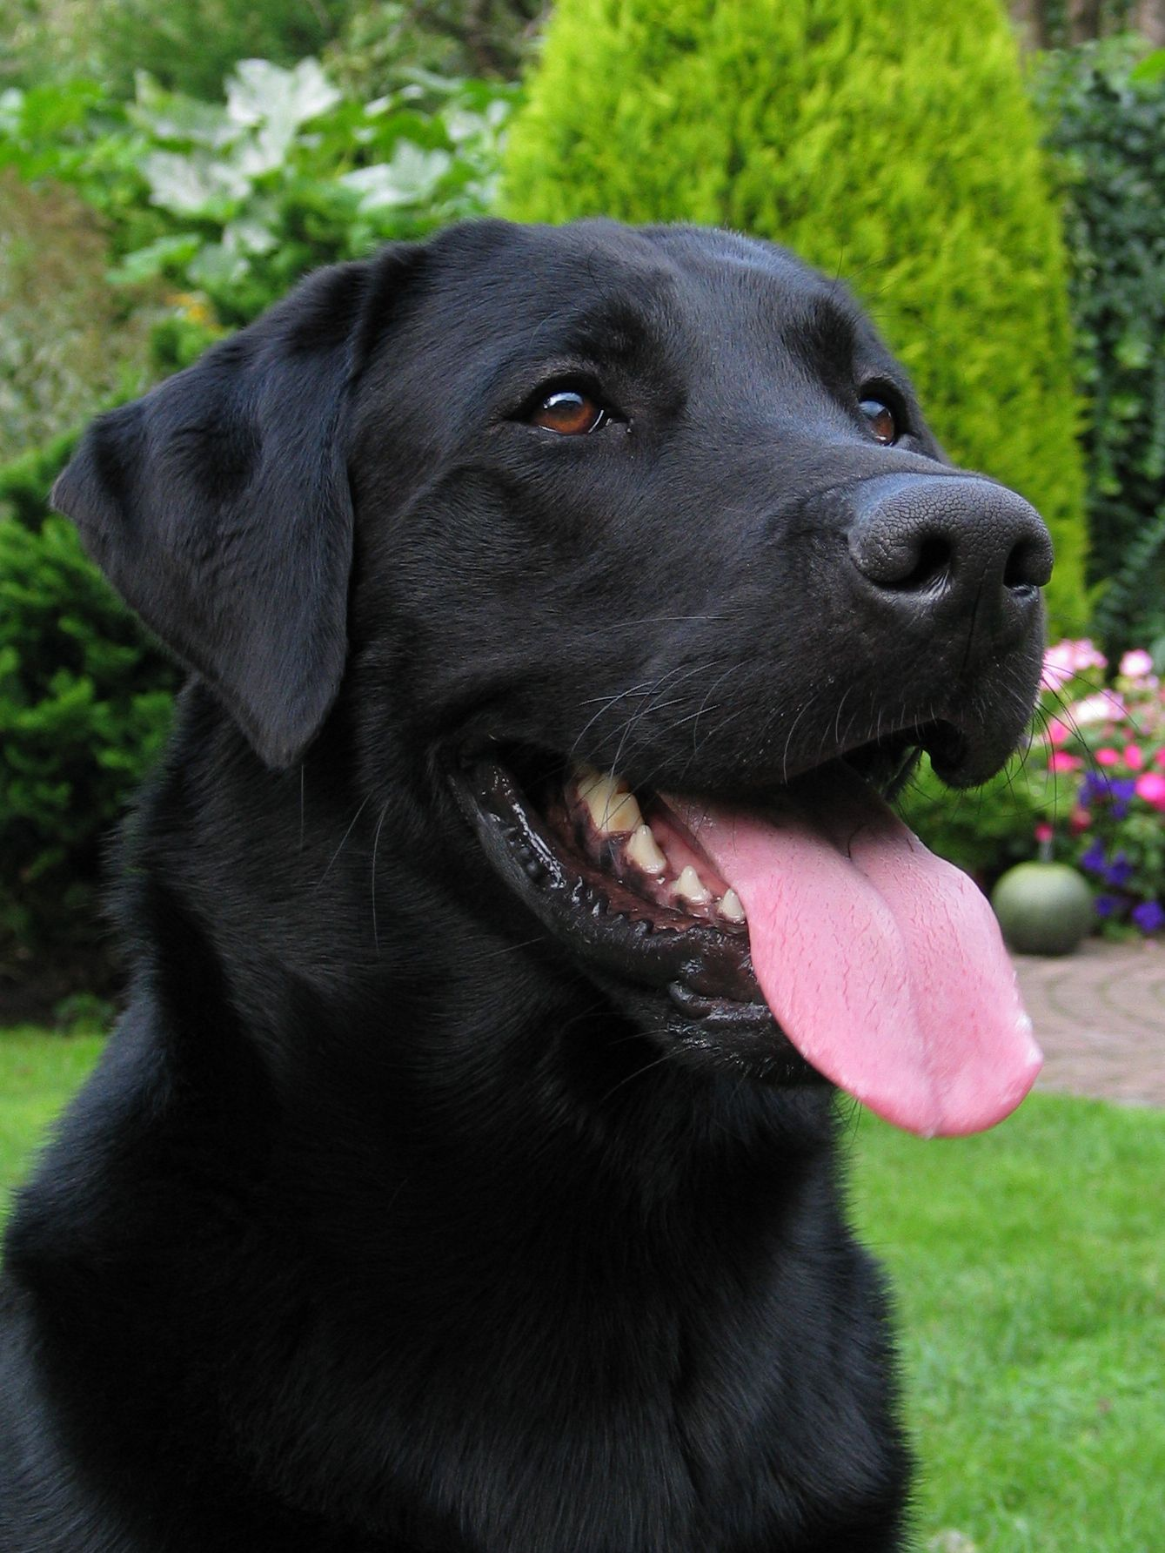

Information for Third Recovered File

Starting Physical Sector Number:14328

Starting Cluster Number:1775

Ending Physical Sector Number: 14416

Ending Cluster Number:1786

Physical size in bytes: 45056

Carved File MD5 Hash: e25026940356f1ba0f24620e8aed05ff

Carved File SHA1 Hash: 04d7fa8396467afa9d3e8786b96830197165b8e8

Insert Recovered Image Below:

